PROJECT PLAN

Weather Forecast
Ivy Tech Community College - SDEV 265
Dr. Steve Carver

Prepared By: | Carlos Cuevas Cadena
 | Marcilia Alves Machado

Table of Contents

Introduction 3
Project organization 4
Risk Analysis 5-7
Hardware and software requirements 16
Work breakdown 8-11
Process Flow Diagrams 18-19
Project schedule 12
Monitoring and reporting mechanisms 14
Appendix 15
Major Dependencies
Hardware Requirements
Software Requirements
email Template
Service Disruptions
Daily weather forecast

Introduction

The purpose of this project is to develop a web-based application that retrieves weather information from a weather API and sends weather updates and alerts to users via email. Users will be able to register their phone number, location, and notification preferences to receive weather forecasts and severe weather alerts.
The application is intended to provide a simple and accessible method for receiving weather information. While internet-based weather applications offer extensive information, they may not always be practical in situations where internet access is limited or expensive. Email notifications allow users to receive important weather information while traveling, roaming internationally, or experiencing unreliable internet connectivity. The system will focus on current weather conditions and forecast alerts and will not include historical weather analysis.

Project Organization

Roles

Carlos - Project manager, planner, organizer, back-end developer, back up designer, and program analyst.
Marcilia - Lead designer , planner, back-end developer, schedule organizer, and program tester.

Risk Analysis

Risk | Risk Level | Probability | Effect
Team members not available and lack of communication | Medium | Team members missing meetings or becoming unavailable is fairly common in student projects. | Delays in task completion, missed deadlines and possible impact on the quality of the final application.
Unrealistic project schedule | Low | The schedule can be impacted if not enough time is allocated for all project specifications during planning. | Unrealistic schedules can cause delays, push the final release date and miss deadlines for final project submission compromising grade.
Overlooked or missing requirement pieces | Low | Projects can experience unfortunate surprises late in the development cycle when critical part aspects are not included. | Impact in the schedule and deployment of the final project
Data privacy | Medium | Security risks arise from system vulnerabilities being increasingly common in modern software. | It may compromise user data privacy generating risks regarding compliance with data protection regulations.
Slow release cycles | Medium | Slow release cycles can compromise schedule, delay bug fixes. | Delays in development, testing or deployment can compromise final schedule, delay final submission and cause users to experience unresolved issues.
API provider dependency | Low | During the development a known provider can be used to limit the risk or multiple APIs can be added to ensure redundancy. | Broken features, slow load times and service outages.
Rate limits | Low | Low risk since the developers can build strict usage limits and alerts into the app, preventing runaway costs. | Exceeding maximum API requests limits set by the data provider can cause temporary service ban or app outages.
Less number of skilled people | Medium | Small team can have limited resources and expertise | Team members may become overloaded with tasks that can lead to slower development, reduce code quality and compromise deadlines.
Equipment failure | Low | Computer and internet failure do not occur frequently. | Failure in team members computer or internet connection may delay development compromising, schedule and project delivery.
Testing | Medium | Testing can be planned and managed, but limited time and resources may cause some defects to go undetected before final deployment. | It can lead to vulnerable software containing errors, bugs and poor user experience.
Wrong/improper budget estimation | Low | The financial aspect of the project will be defined beforehand lowering the risk of improper budget estimation. | Cost overruns can disrupt financial planning and threaten project completion.

Work Breakdown
Week One:
-Team set up

- Meet the team that is going to work on the project
- Determine strengths and weakness of each team member
- Define roles of each team members

-Communication/Meetings setup

- Define communication approaches
- Establish meeting schedule
- Establish a protocol for after hours or emergency communication

Week Two:
-Conceptualization

- Determine the purpose and scale of the project
- Determine the resources required for the project
- Project the cost and feasibility of the project

-Preperation

- Create access pathways for the necessary the resources
  - Set up editors
  - Create accounts for websites
  - Pay any required subscriptions
- Determine legality
  - Research terms and conditions of the involved programs
  - Review limits of use of the involved program to determine if it is appropriate for the scale of the project
  - Review third party terms and conditions
- Produce a development schedule, detailing the days, time, and labor spent of each part of the development cycle

Week Three:

-Documentation

- Produce work and role schedule for team members
  - list the team members and the roles of the members of the team
- Produce a work break down plan
  - how the project is broken into activities
- Produce project schedule
  - dependencies between activities
- Charts and diagrams
  - Development cycle chart
  - Program operation chart
  - Tasks and productivity chart

-Sudocode defining the program

Week Four:

-Project set up

- Design document
- Folder set up
- Classes and Libraries that are going to be used

-Development

- Begin coding the core of the program
  - Skeleton code as a foundation to build upon
  - Code a simplistic version of the program to make sure it can fulfil its purpose
-Team meeting

- Discuss progress

Week Five:

-In Depth Development

- Code all program functionality
  - Main systems of the program are coded
  - Program is producing expected results

-Refactoring and Refinement

- Refactoring code for better optimization
- Refine code for improved results, visually appealing, and readability

-Team meeting

- Discuss progress

Week Six:

-Finishing up development

- Most of the programs functionality will be completed
  - Expected final results will be produced
  - Results Properly formatted

- Security refinement
  - Security protocols implemented

-Testing

- Program will be tested for bugs, glitches, and unintended behaviors
- Check for security vulnerabilities
  - Back-end review
  - Front-end review (if any)
  - Address third-party risks

-Team Meeting

- Discuss progress

Week Seven:

-Deployment

- Deploy the project to a hosting website

-Documentation

- Write documents explaining the application

-Team meeting

- Discuss progress and presentation

Week Eight:

-Presentation

- Present the application
  - Explain the functionality
  - Demonstrate the features

Project schedule

Dependencies between activities
- Feasibility Study → Risk Assessment
- Risk Assessment → Requirements Document
- Requirements Document → Project Plan
- Requirements Document → Process Flow Diagram
- Requirements Document → System Architecture
- Project Plan → Environment Setup
- Environment Setup → Development Activities
- Development Activities → Testing
- Testing → Documentation
- Documentation → Final Presentation

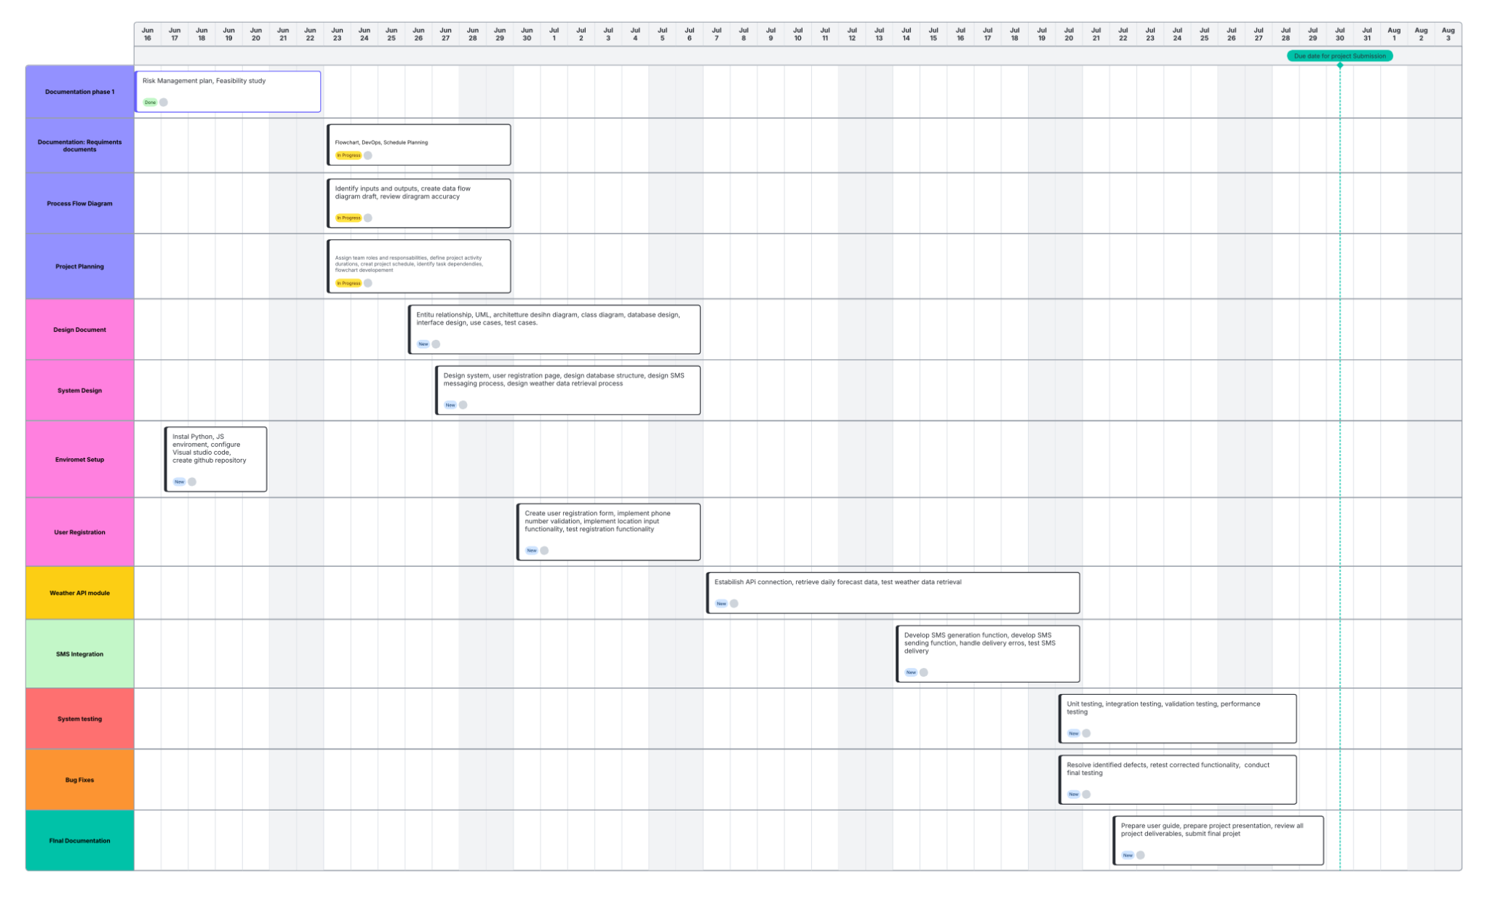
Project Timeline

Monitoring and reporting mechanisms
The team will use:
- Discord and Ivy tech group chat in canva – communication and sharing project documents.
- Trello – task organization and progress tracking.
- Lucid chart – create the project schedule calendar.
- GitHub – for version control, code sharing, and collaboration during development.

Appendix

Major Dependencies
    - Feasibility Study → Risk Assessment
    - Risk Assessment → Requirements Document
    - Requirements Document → Project Plan
    - Requirements Document → Process Flow Diagram
    - Requirements Document → System Architecture
    - Project Plan → Environment Setup
    - Environment Setup → Development Activities
    - Development Activities → Testing
    - Testing → Documentation
    - Documentation → Final Presentation

Hardware and software requirements

Hardware:
-Windows 10-current version
-2.4 GB Ram
-Any dual core from the last 10 years(2016-current)
-At least 128GB of disk space

Software Requirements

Python 3.x
HTML
CSS
JavaScript
Git
GitHub
GitHub Actions
Twilio API
Open Weather API
Visual Studio Code

Process Flow and Productivity Diagrams

